Appointment Date and Time: ________________________________________
1001 Bellfontaine Ave, Lima, Ohio 45804
Traveling on State Route 117/309 by Lima Memorial Hospital on Bellefontaine Ave in Lima:
Turn North on to South Dewey Ave. –Happy Daz is at that intersection;
Turn Left into parking lot just past Linden Ave. Park in the parking lot for the Professional Office Building II
Enter the Professional Office Building II under the PATIENT ENTRANCE sign.
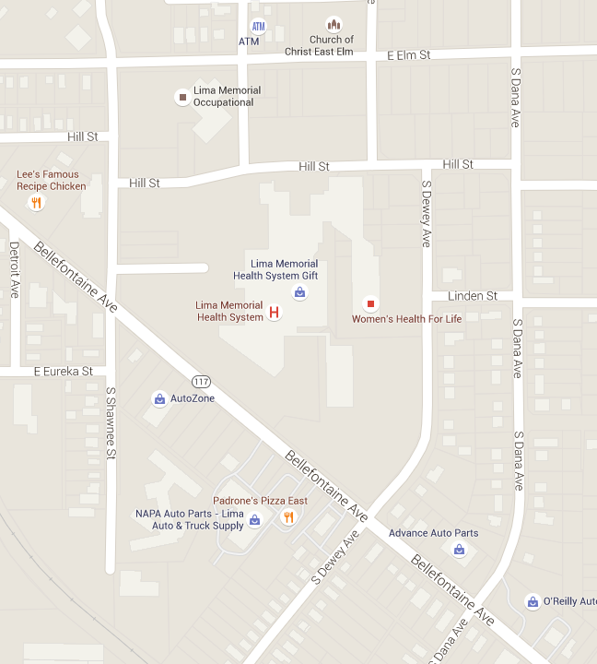
\
\

P
A
R
K
I
N
G
Professional Office Building II

Happy Dayz

Locating the Child Advocacy Center at Lima Memorial Hospital from the Professional Office Building / Patient Entrance.
Here's where you enter:
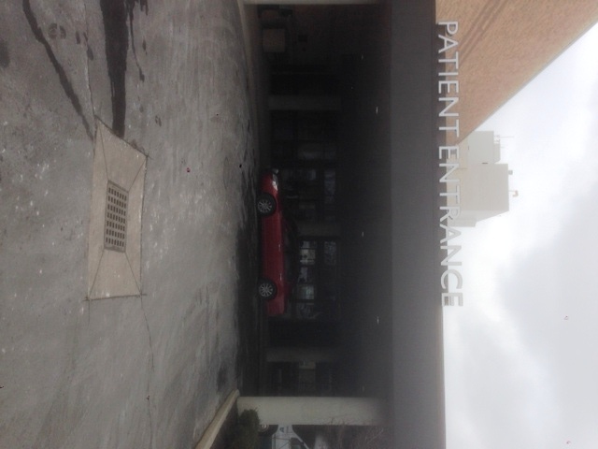

INSIDE BUILDING:
Once inside, angle to the right toward the Patient Services building. Keep to the right as you pass the admitting/registration area.
Now turn left where you see the sign for the "Wound Care Center." Here's where you turn:
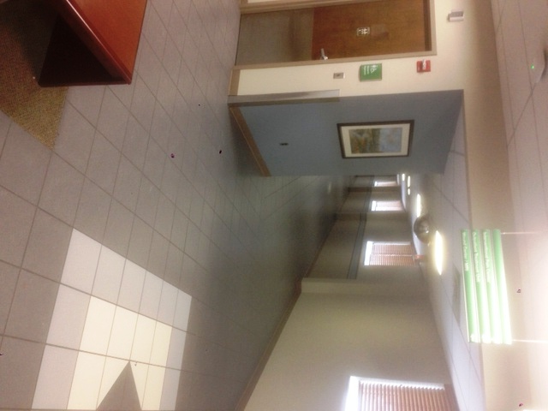

At the end of the hall turn right. Here's what you'll see:
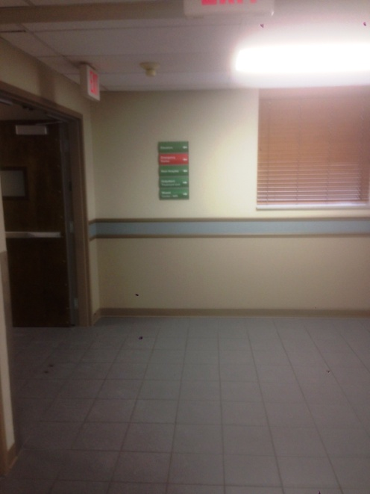
You're almost there. Look for the "Kid's Clinic" sign near the end of the hall.
